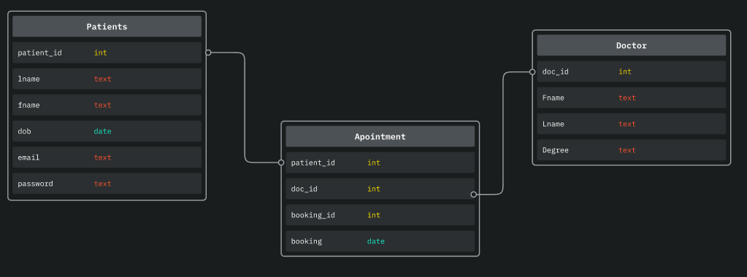
Well the patient table has the patient id which is a self indexing integer; which have their first and last name and their date of birth so we can make sure that the user is on the system. The doctor table haves the doctor id for quick and unique identification as well as there first and last name and if do have a speciality and the Appointment table where the primary key of patient and Doctor become foreign key

